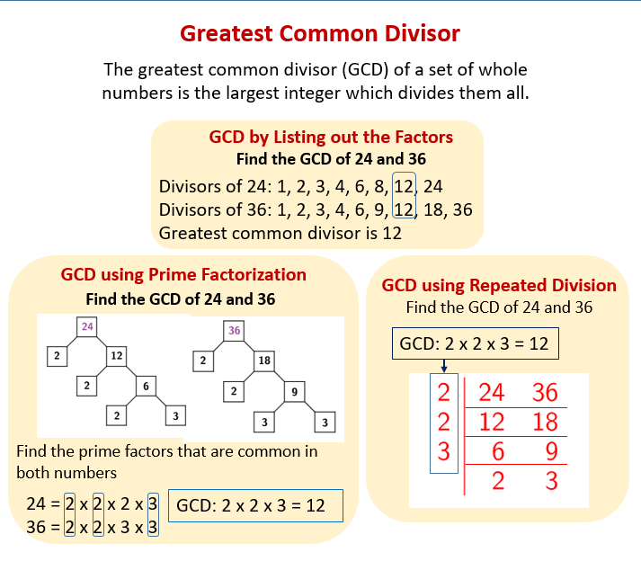

Calculate the greatest common divisor of the following numbers:

Example

GCD (128, 196) = ?

Solution:

$$128=2∙64=2∙2∙32=2∙2∙2∙16=2∙2∙2∙2∙8=2∙2∙2∙2∙2∙4=2∙2∙2∙2∙2∙2∙2$$

$$196=2∙98=2∙2∙49=2∙2∙7∙7$$

so, we can see the common divisors:

$$128=2∙2∙2∙2∙2∙2∙2$$

$$196=2∙2∙7∙7$$

that means 4 can divide both 128 and 196.

Answer: GCD(128, 196) = 4

**Exercise:**

1. GCD(648,  324) = 4 (10 marks)

648=2x2x2x3x3x3x3

324=2x2x3x3x3x3

1. GCD(102,  204) = 2x3x17 = 102 (2 marks)
$$102=2×3×17$$

$$204=2×2×3×17$$

2. GCD(966,  345)= 69 (2 marks)

966=2.3.7.23

345=5.3.23

1. GCD(396,  660)=~~2~~ 132 (1 marks)

396=3.2.2.3.11

660=2.2.5.11 = 2 x 2 x 3 x 5 x 11

1. GCD(604,  453)=~~6~~ 151 (2 marks)

604=2.2.151

453=3.151

1. GCD(910,  390)=~~4~~ 130 (2 marks)

910=2.5.91 = 2x5x7x13

390=2.5.3.13

1. GCD(460,  575)=4 115 (2 marks)

460=2.2.5.23

575=5.5.23

1. GCD(230,  805)=~~2~~ 115 (2 marks)

230=5.2.23

805=5.7.23

1. GCD(438,  146) = 146 (2 marks)

438=2.3.73

146=2.73

1. GCD(783,  348)=2 87 (2 marks)

783=3.3.29

348=2.3.29

You gain: 27 %